**A Numerical Solution of XX Differential Equation**

Burcu Yıldırım1,2

1Institute of Mathematics, Johannes Gutenberg-University of Mainz, Mainz, Germany,

2Department of Computer Engineering, Üsküdar University, İstanbul, Turkey,

E-mail: burcu.gurbuz@uni-mainz.de

**Abstract**

In this study, a numerical approach for the solution of Riccati differential equation is investigated. Nonlinear Riccati differential equations have been used in many fields in science, engineering and especially in applied mathematics. A numerical solutions are obtained with regard to a matrix method and compared with other techniques in literature. Besides, error analysis is given in order to obtain more efficient results for its approximation.

***Keywords:*** Riccati differential equation, matrix method, orthogonal polynomials.

**1. Introduction**

Riccati differential equations are of great importance in many areas in control theory, supply-demand relationship, social practise theory, biology, free vibration theory, forecasting and some other applications in science and engineering fields [1]-[3]. Both analytical and numerical solutions of different types of Riccati differential equation have been investigated by many techniques. These applications are important due to its support to other research areas. There has been many well-known techniques such as Padé approximation method [4], operation matrix method [5], Taylor matrix method [6], decomposition method [7], Bernstein polynomial approach [8], [9], Fourier polynomial approximation [10], classical fourth order Runge Kutta method [11], variational iteration algorithm [12] and so on.

In this study, the following type Riccati differential equation is defined in the form:

 (1)

**2. Preliminaries**

***Properties of Jacobi Polynomials***

Jacobi polynomials are commonly known as hypergeometric polynomials since they play an important role in rotation groups and classification of molecular rotors in quantum mechanics. Jacobi polynomials are defined in the form:

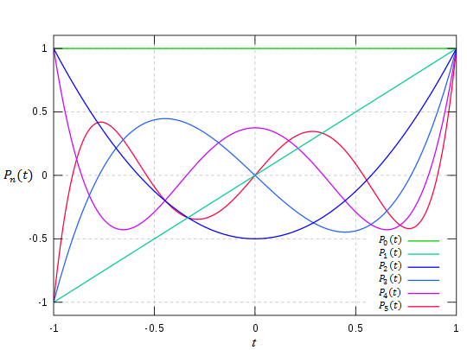

**Figure 1.** Legendre polynomials for  and  [21].

**3. Numerical Technique**

**Definition:** The collocation method is a numerical method which is applicable pointwise in order to get the numerical solution of the problem i.e. a finite-dimensional space of candidate solutions.

**4. Accuracy of Solution**

In this section, we check the accuracy of the present method. The approximate solutions  of Eq. (1), and their first derivatives are considered and substituted into Eq. (1). Then we obtain approximate results for 

**5. Numerical Experiments**

**Example 1.** Let us first consider the following Riccati differential equation [33]

 (23)

The numerical technique which is introduced at Section 3 applied on the problem (23) for . Then the collocation points are shown as

**6. Conclusion**

In this study, we introduce a matrix method depending on Jacobi polynomials in order to solve nonlinear Riccati type differential equation with initial condition numerically. Furthermore, the accuracy of the solution is obtained by an error analysis.

**7. References**

1. Dragan, V., Aberkane, S., Morozan, T. 2020. On the bounded and stabilizing solution of a generalized Riccati differential equation arising in connection with a zero‐sum linear quadratic stochastic differential game. Optimal Control Applications and Methods, 41(2), 640-667.
2. Xiao, Q., Gao, M., Xiao, X., Goh, M. 2020. A novel grey Riccati–Bernoulli model and its application for the clean energy consumption prediction. Engineering Applications of Artificial Intelligence, 95, 103863.
3. Razzaghi, M. 1979. A computational solution for a matrix Riccati differential equation. Numerische Mathematik, 32(3), 271-279.