**A Numerical Approach to Solution of Nonlinear Riccati Differential Equation**

Burcu Gürbüz1,2

1Institute of Mathematics, Johannes Gutenberg-University of Mainz, Mainz, Germany,

2Department of Computer Engineering, Üsküdar University, İstanbul, Turkey,

E-mail: burcu.gurbuz@uni-mainz.de

**Abstract**

In this study, a numerical approach for the solution of Riccati differential equation is investigated. Nonlinear Riccati differential equations have been used in many fields in science, engineering and especially in applied mathematics. A numerical solutions are obtained with regard to a matrix method and compared with other techniques in literature. Besides, error analysis is given in order to obtain more efficient results for its approximation.

***Keywords:*** Riccati differential equation, matrix method, orthogonal polynomials.

**1. Introduction**

Riccati differential equations are of great importance in many areas in control theory, supply-demand relationship, social practise theory, biology, free vibration theory, forecasting and some other applications in science and engineering fields [1]-[3]. Both analytical and numerical solutions of different types of Riccati differential equation have been investigated by many techniques. These applications are important due to its support to other research areas. There has been many well-known techniques such as Padé approximation method [4], operation matrix method [5], Taylor matrix method [6], decomposition method [7], Bernstein polynomial approach [8], [9], Fourier polynomial approximation [10], classical fourth order Runge Kutta method [11], variational iteration algorithm [12] and so on.

In this study, the following type Riccati differential equation is defined in the form:

 (1)  
where  is an arbitrary constant, and are continuous given functions.

The organization of the paper is the following. Initially, preliminaries about polynomials are given. Then the numerical method for finding the approximate solution of the problem is proposed. Afterward, an error analysis is introduced. Accordingly, numerical results of the problem are given by tables and figures. The paper finalizes with the concluding remarks and brief discussion of results.

**2. Preliminaries**

***Properties of Jacobi Polynomials***

Jacobi polynomials are commonly known as hypergeometric polynomials since they play an important role in rotation groups and classification of molecular rotors in quantum mechanics. Jacobi polynomials are defined in the form:

 (2)

where  and  are parameters with the relation [13]-[20]. Then the first few Jacobi polynomials are given from Eq. (2) as

(3)  
**Definition:** Jacobi polynomials are have the cases within the special concept of  and  parameters as

**Case 1.** For , we have the relation

 (4)

which is called as the *Legendre polynomials* (Fig. 1).

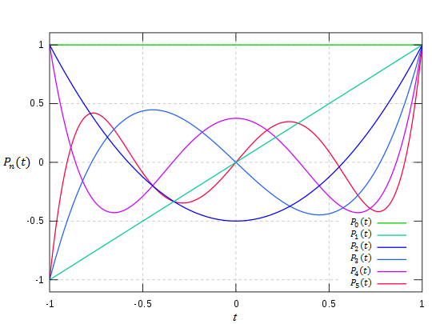

**Figure 1.** Legendre polynomials for  and  [21].

**Case 2.** For , we have the relation

 (5)

which is called as the *Chebyshev polynomials of the first kind* (Fig. 2).

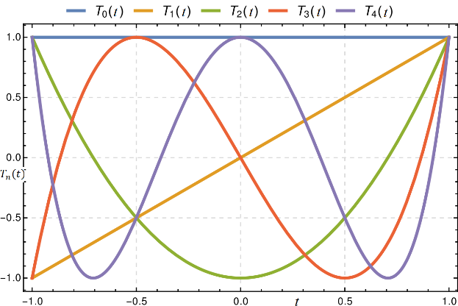

**Figure 2.** Chebyshev polynomials of the first kind for  and  [22].

**Case 3.** For , we have the relation

 (6)

which is called as the *Gegenbauer polynomials* (Fig. 3).

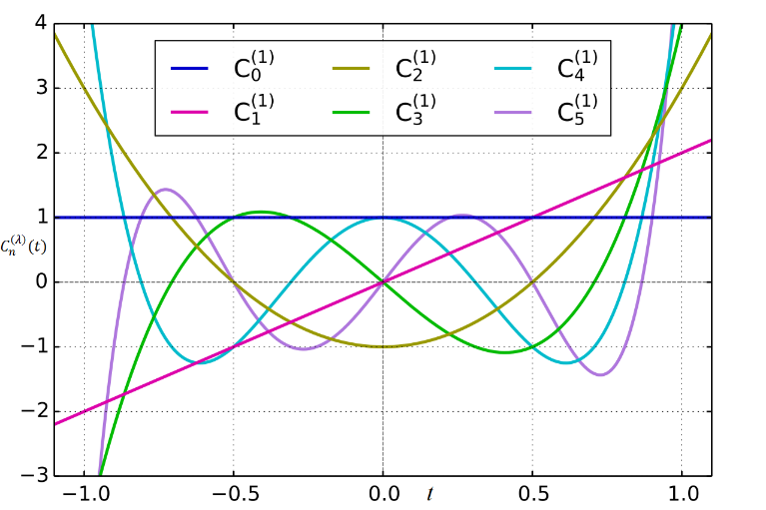

**Figure 3.** Gegenbauer polynomials for  and  and  [23], [24].

**3. Numerical Technique**

In this section, an approximate solution in terms of orthogonal Jacobi polynomials is presented in the form:

, (7)

where  are unknown coefficients,  is approximate solution for any integer  and  are the orthogonal Jacobi polynomials defined in Eq.(2). For this purpose, Eq. (1) is considered in the form , (8)

where



Then the orthogonal Jacobi polynomials are transformed into the matrix form as

, (9)

where

, (10)

and

 (11)

By using the relations from (8) and (9),

, (12)

Now, the relation between  and its first derivative  is shown as

, (13)

where

.

Then the derivative part of the problem is defined in the matrix form as

, (13)

Besides, the nonlinear term of the Riccati equation has a matrix form as

, (14)

where



The coefficients  and  of Eq. (1) are also defined in matrix form as



So that the matrix system of the nonlinear Riccati differential equation in Eq.(1) is described as

 (15)

**Definition:** The collocation method is a numerical method which is applicable pointwise in order to get the numerical solution of the problem i.e. a finite-dimensional space of candidate solutions. This is accepted that “selected points” or collocation principle over the set of points are called as *collocation points* in order to implement the collocation based methods [25]-[27]. Here, the collocations points are defined as

 (16)

The approximation of the problem is found pointwise and we use the collocation points which is defined in Eq.(16). Substituting the collocation points into Eq.(15),

 (17)

where



Eq.(17) is obtained as the fundamental matrix relation which can be also written as

 (18)

where “” is the sign to separate the coefficient matrices. Let us consider Eq.(18) in a brief form

 and  (19)

and then

 or  (20)

Besides, matrix representation of the initial condition is obtained by using the similar procedure. Then it is found as

 (21)

By replacing the matrices (21) into the system (20) then new augumented matrix system is obtained in the form . Then with the solution of the system by using Gauss Elimination procedure, the unknown coefficients are found and replaced in Eq. (7). Consequently, numerical solution is obtained [28]-[31].

**4. Accuracy of Solution**

In this section, we check the accuracy of the present method. The approximate solutions  of Eq. (1), and their first derivatives are considered and substituted into Eq. (1). Then we obtain approximate results for 

 (22)

where ( is a positive integer) is prescribed, then the truncation limit *N* is increased until difference  becomes smaller than the prescribed  at each points [32].

**5. Numerical Experiments**

In this section, to show the accuracy and efficiency of the presented method, for the problem given at (1), is solved with it. Numerical calculations and plottings were performed using Maple and Matlab softwares, respectively.

**Example 1.** Let us first consider the following Riccati differential equation [33]

 (23)

The numerical technique which is introduced at Section 3 applied on the problem (23) for . Then the collocation points are shown as

 (24)

So that we have the following matrices

 

  

and the fundamental matrix relation as

 i.e.



together with the matrix relation of the condition,  we have the new augumented matrix form as . Finally, we obtain the approximate solution in the form:



Then we investigate the approximate solutions for different polynomials with regard to the pair  Jacobi polynomials and Gegenbauer polynomials. Finally, the exact solution  is obtained for .

**Example 2.** Here, Riccati differential equation is considered [33], [34]

 (24)

The exact solution is , for .

By using the procedure, we obtain the approximate solutions. The approximate solutions for different N values can be seen in Table 1 and Fig. 1. The comparison of approximate solutions with different techniques and the exact solution is shown by Fig. 2.

**Table 1.** Absolute errors for N=3, 4 and 8 of Example 2.

|  |  |  |  |
| --- | --- | --- | --- |
| *t* |  |  |  |
| 0.1 | 0.1510E-03 | 0.9475E-04 | 0.1200E-05 |
| 0.2 | 0.1144E-04 | 0.2319E-05 | 0.9025E-06 |
| 0.5 | 0.1491E-04 | 0.2467E-05 | 0.9866E-06 |
| 0.6 | 0.1789E-04 | 0.2546E-05 | 0.9157E-06 |
| 1 | 0.1431E-04 | 0.2422E-05 | 0.9692E-06 |

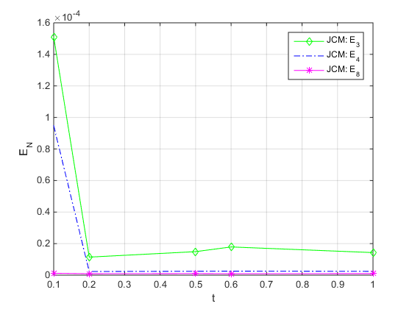

**Figure 1.** Comparison of absolute errors for N= 3,4 and 8 of Jacobi polynomial solution.

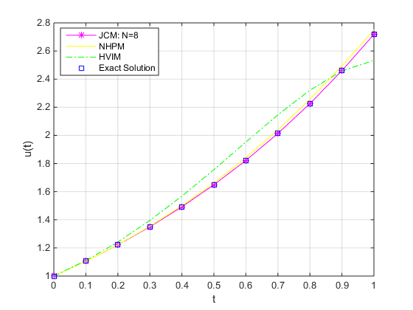

**Figure 2.** Comparison of approximate solutions between Jacobi Collocation Method (JCM) for N=8, He’s variational iteration method (HVIM) and new homotopy perturbation method (NHPM).

**6. Conclusion**

In this study, we introduce a matrix method depending on Jacobi polynomials in order to solve nonlinear Riccati type differential equation with initial condition numerically. Furthermore, the accuracy of the solution is obtained by an error analysis. The present method and its error analysis are applied on the example which have been shown by figures and table. The method has significant advantages such as: straightforward computation procedure together with some computer programme algorithm in Maple. We obtain satisfactory results whenever we have N is chosen large enough. The method is applicable for further problems and their applications at interdiciplinary area [35]-[37].

**7. References**

1. Dragan, V., Aberkane, S., Morozan, T. 2020. On the bounded and stabilizing solution of a generalized Riccati differential equation arising in connection with a zero‐sum linear quadratic stochastic differential game. Optimal Control Applications and Methods, 41(2), 640-667.
2. Xiao, Q., Gao, M., Xiao, X., Goh, M. 2020. A novel grey Riccati–Bernoulli model and its application for the clean energy consumption prediction. Engineering Applications of Artificial Intelligence, 95, 103863.
3. Razzaghi, M. 1979. A computational solution for a matrix Riccati differential equation. Numerische Mathematik, 32(3), 271-279.
4. Alzate, P.P.C., Orrego, Á.A.Q. 2020. A note on quadratic Riccati differential equation using Padé approximant, International Journal of Engineering Technologies and Management Research, 7(6), 117-124.
5. Parand, K., Hossayni, S.A., Rad, J.A. 2016. Operation matrix method based on Bernstein polynomials for the Riccati differential equation and Volterra population model. Applied Mathematical Modelling, 40(2), 993-1011.
6. Gülsu, M., Sezer, M. 2006. On the solution of the Riccati equation by the Taylor matrix method. Applied Mathematics and Computation, 176(2), 414-421.
7. Bulut, H., Evans, D.J. 2002. On the solution of the Riccati equation by the decomposition method. International Journal of Computer Mathematics, 79(1), 103-109.
8. Gürler, H., Yalçınbaş, S. 2015. A new algorithm for the numerical solution of the first order nonlinear differential equations with the mixed non-linear conditions by using Bernstein polynomials, New Trends in Mathematical Sciences, 3(4), 114.
9. Yüzbaşı, Ş. 2013. Numerical solutions of fractional Riccati type differential equations by means of the Bernstein polynomials. Applied Mathematics and Computation, 219(11), 6328-6343.
10. Bülbül Aslan, B. 2019. Solving Riccati differential equation using Fourier polynomial basis.
11. File, G., Aga, T. 2016. Numerical solution of quadratic Riccati differential equations. Egyptian journal of basic and applied sciences, 3(4), 392-397.
12. Ghorbani, A., Momani, S. 2010. An effective variational iteration algorithm for solving Riccati differential equations. Applied Mathematics Letters, 23(8), 922-927.
13. Abramowitz, M., Stegun, C.A. 1972. Orthogonal Polynomials, Ch. 22 in Handbook of Mathematical Functions with Formulas, Graphs, and Mathematical Tables, 9th Ed. New York: Dover, 771-802.
14. Iyanaga, S., Kawada, Y., 1980. Jacobi Polynomials, Appendix A, Table 20.V in Encyclopedic Dictionary of Mathematics. Cambridge, MA: MIT Press, 1480.
15. Szegö, G. 1975. Jacobi Polynomials, Ch. 4 in Orthogonal Polynomials, 4th Ed. Providence, RI: Amer. Math. Soc.
16. Jacobi Polynomial, <http://intranet-statique.mines-albi.fr/crcmath/math/math/j/j023.htm>, 2020.
17. Luke, Y. 1969. The Special Functions and Their Approximations, Academic Press, New York, NewYork, USA.
18. Doha, E.H. 2002. On the coefficients of differentiated expansions and derivatives of Jacobi polynomials. Journal of Physics A: Mathematical and General, 35(15), 3467.
19. Chihara, T.S. 1978. An Introduction to Orthogonal Polynomials (Dover Books on Mathematics), Gordon and Breach. Dover, Philadelphia.
20. Weisstein, E.W. 2020. Jacobi Polynomial, From MathWorld-A Wolfram Web Resource. https://mathworld.wolfram.com/JacobiPolynomial.html.
21. Legendre polynomials, https://en.wikipedia.org/wiki/Legendre_polynomials, 2020.
22. Chebyshev polynomials, https://en.wikipedia.org/wiki/Chebyshev_polynomials, 2020.
23. Gegenbauer polynomials, https://en.wikipedia.org/wiki/Gegenbauer_polynomials, 2020.
24. Askey, R. 1975. Orthogonal polynomials and special functions. Society for Industrial and Applied Mathematics.
25. Itô, K. 1980 Methods Other than Difference Methods, §303I in Encyclopedic Dictionary of Mathematics, 2nd Ed., Vol:2. Cambridge, MA: MIT Press, 1139.
26. Wright, K. 1970. Some relationships between implicit Runge-Kutta, collocation and Lanczos methods, and their stability properties, 10, 217-227.
27. Lanczos, C. 1957. Applied Analysis, Pitman & Sons Ltd.
28. Gürbüz, B., Sezer, M. 2020. Modified operational matrix method for second-order nonlinear ordinary differential equations with quadratic and cubic terms, An International Journal of Optimization and Control: Theories & Applications (IJOCTA), 10(2), 218-225.
29. Gürbüz, B., 2020. A computational approach for solving second-order nonlinear ordinary differential equations by means of Laguerre series, Bitlis Eren Üniversitesi Fen Bilimleri Dergisi, 9(1), 78-84.
30. Ganji, R.M., Jafari, H. 2019. A numerical approach for multi-variable orders differential equations using Jacobi polynomials. International Journal of Applied and Computational Mathematics, 5(2), 34.
31. Opanuga, A.A., Edeki, S., Okagbue, H.I., Akinlabi, G. 2015. A novel approach for solving quadratic Riccati differential equations. International Journal of Applied Engineering Research, 10(11), 29121-29126.
32. Gürbüz, B., Sezer, M. 2016. Laguerre polynomial solutions of a class of initial and boundary value problems arising in science and engineering fields. Acta Physica Polonica A, 130(1), 194-197.
33. Aminikhah, H. 2013. Approximate analytical solution for quadratic Riccati differential equation.
34. Abbasbandy, S. 2007. A new application of He's variational iteration method for quadratic Riccati differential equation by using Adomian's polynomials. Journal of Computational and Applied Mathematics, 207(1), 59-63.
35. Christianto, V., Ershkov, S.V. 2018. Two Applications of Riccati ODE in Nonlinear Physics and Their Computer Algebra Solutions. Victor Christianto| Florentin Smarandache, 132.
36. Nowakowski, M., Rosu, H.C. 2002. Newton’s laws of motion in the form of a Riccati equation. Physical Review E, 65(4), 047602.
37. Doha, E.H., Baleanu, D., Bhrawi, A.H. ,Hafez, R.M. 2014. A Jacobi collocation method for Troesch’s problem in plasma physics, Proceedings of the Romanian Academy, Series A, 15(2), 130-138.